1. Retrieve all columns from the product table.

Query - SELECT* FROM products;

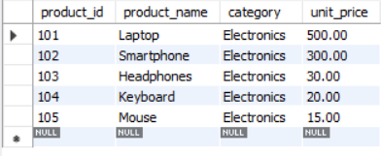

1. Retrieve the product_name and unit_price from the Products table.

Query - select product_name , unit_price from products;

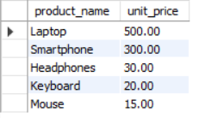

1. Filter the Products table to show only products in the Electronics category.

Query - select product_name from products;

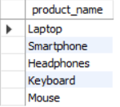

1. Retrieve the product_id and product_name from the Products table for products with a unit_price greater than $100.

Query - Select product_id,product_name from products where unit_price>100;

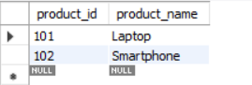

1. Calculate the average unit_price of products in the Products table.

Query - SELECT avg(unit_price) as avg from products;



1. Retrieve the product_name and unit_price from the Products table, ordering the results by unit_price in descending order.

Query - SELECT product_name,unit_price from products order by unit_price desc;

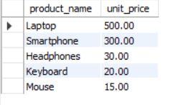

1. Retrieve the product_name and unit_price from the Products table, filtering the unit_price to show only values between $20 and $600.

Query - Select product_name,unit_price from products where unit_price between 20 and 600;

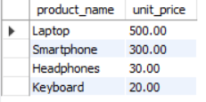

1. 9. Retrieve the product_name and category from the Products table, ordering the results by category in ascending order.

Query-SELECT product_name, category from products order by category AS

SALES

**1. Retrieve all columns from the Sales table.**

**QUERIES:** SELECT * FROM sales;

**2. Retrieve the sale_id and sale_date from the Sales table.**

**QUERIES:** SELECT sale_id, sale_date from sales;

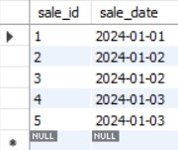

**3. Filter the Sales table to show only sales with a total_price greater than $100.**

**QUERIES:** SELECT * FROM sales where total_price > 100;

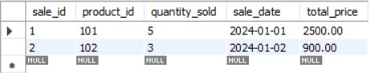

1. **Retrieve the sale_id and total_price from the Sales table for sales made on January 3, 2024. QUERIES:** SELECT sale_id, total_price from sales where sale_date = '2024-01-03';

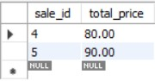

1. **Calculate the total revenue generated from all sales in the Sales table.**

**QUERIES:** SELECT sum(total_price) as total_revenue from sales;



**6. Calculate the total quantity_sold from the Sales table.**

**QUERIES:** SELECT sum(quantity_sold) as total_quantity from sales;



**7. Retrieve the sale_id, product_id, and total_price from the Sales table for sales with a quantity_sold greater than 4.**

**QUERIES:** SELECT sale_id,product_id,total_price from sales where quantity_sold > 4;

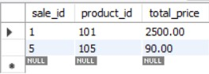

**8. Calculate the average total_price of sales in the Sales table.**

**QUERIES:** SELECT avg(total_price) as avg_price from sales;

